1. Program : A program is a sequence of instruction written in programming languages

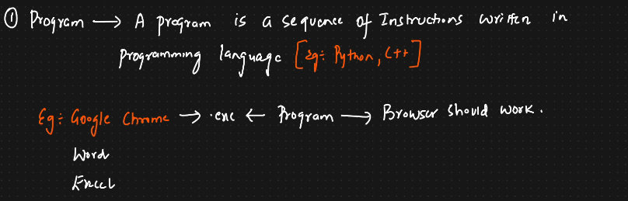

2) Process : it is an instance of a program that is being executed

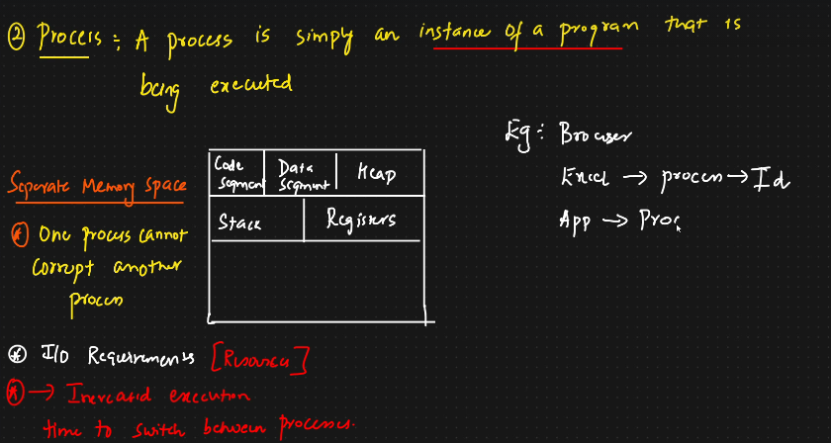

3)Thread : A thread is a unit of execution within a process

